POLLING DIVISION 1 – SALEM AREA
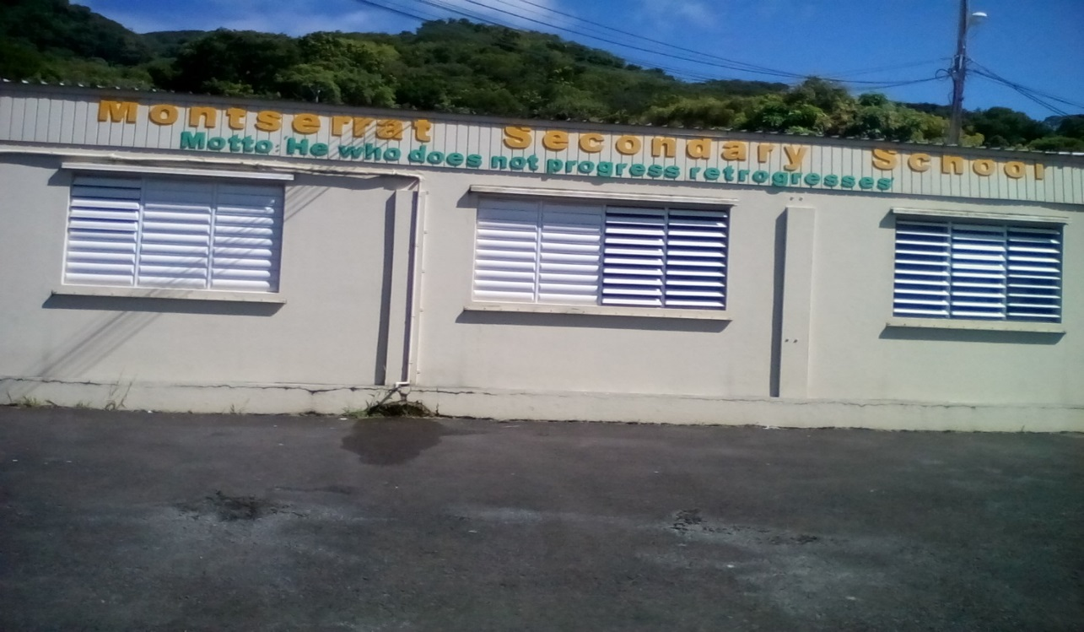

Polling Division 1 is located at the Montserrat Secondary School and consists of two Polling Stations. This Polling Division is for persons living in the Salem area that comprises: Salem , Frith’s, Glebe, Hope, Flemmings, Isles Bay, Old Towne, Olveston and Lime Kiln.
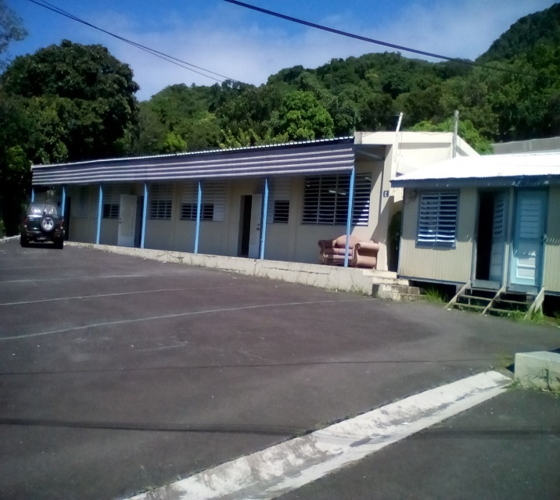
Persons with Surnames A- J would go to Polling Station # 1 and the Presiding Officer is Ms Edith Duberry.

STATION ONE: THE HALL

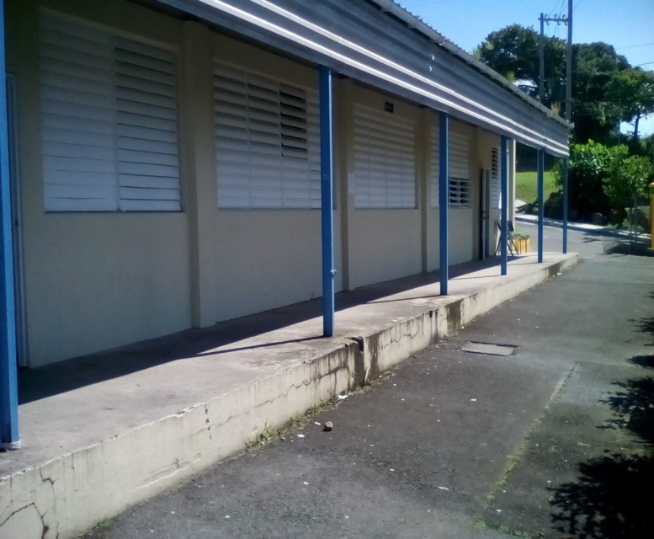
Persons with Surnames K-Z they would go to Polling Station # 2 and their Presiding Officer would be Ms Mary James.

STATION 2:
THE HOME ECONOMICS LAB

POLLING DIVISION 2 – ST. PETER’S AREA
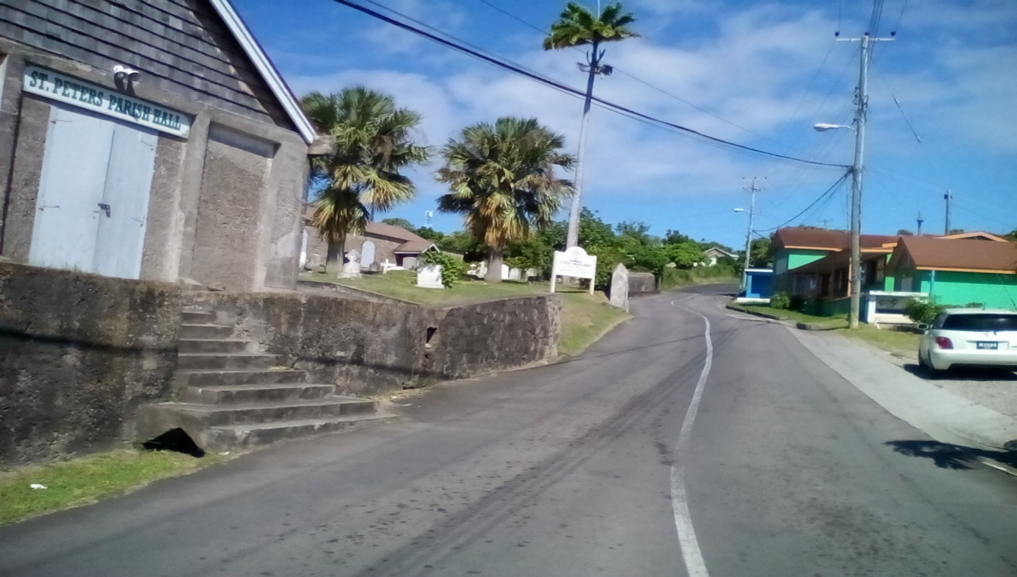
Polling Division 2 caters to voters in the St.Peter’s area and consists of two Polling Stations. The St. Peter’s area comprises: Woodlands, Cheap End, Palm Loop, St. Peter’s, Forgathy, Virgin Islands, Providence, Jones Hill, Woodrupt and Mars Hill.

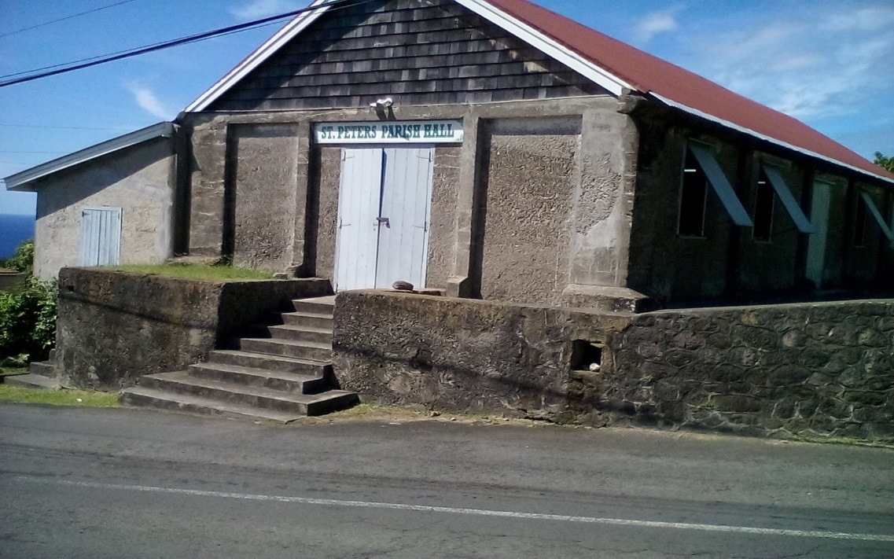
For persons with Surnames A- J they would go to Polling Station # 1 and the Presiding Officer is Mrs Cheverlyn Williams-Kirnon.

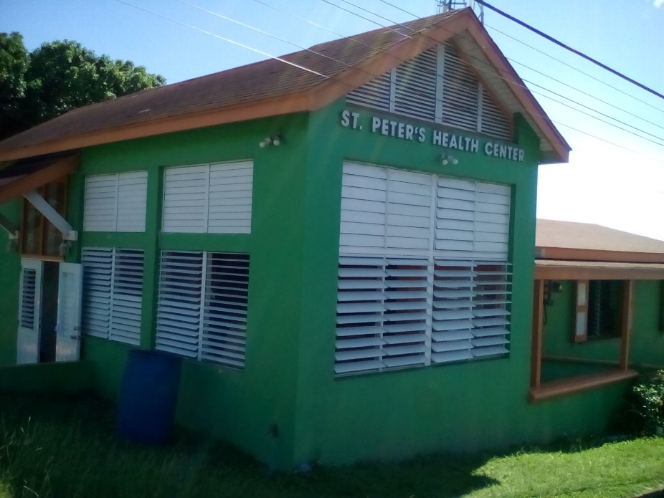
Persons with Surnames K-Z they would go to Polling Station # 2 and their Presiding Officer is Mr Roland Irish.

POLLING DIVISION 3 – BRADES AREA
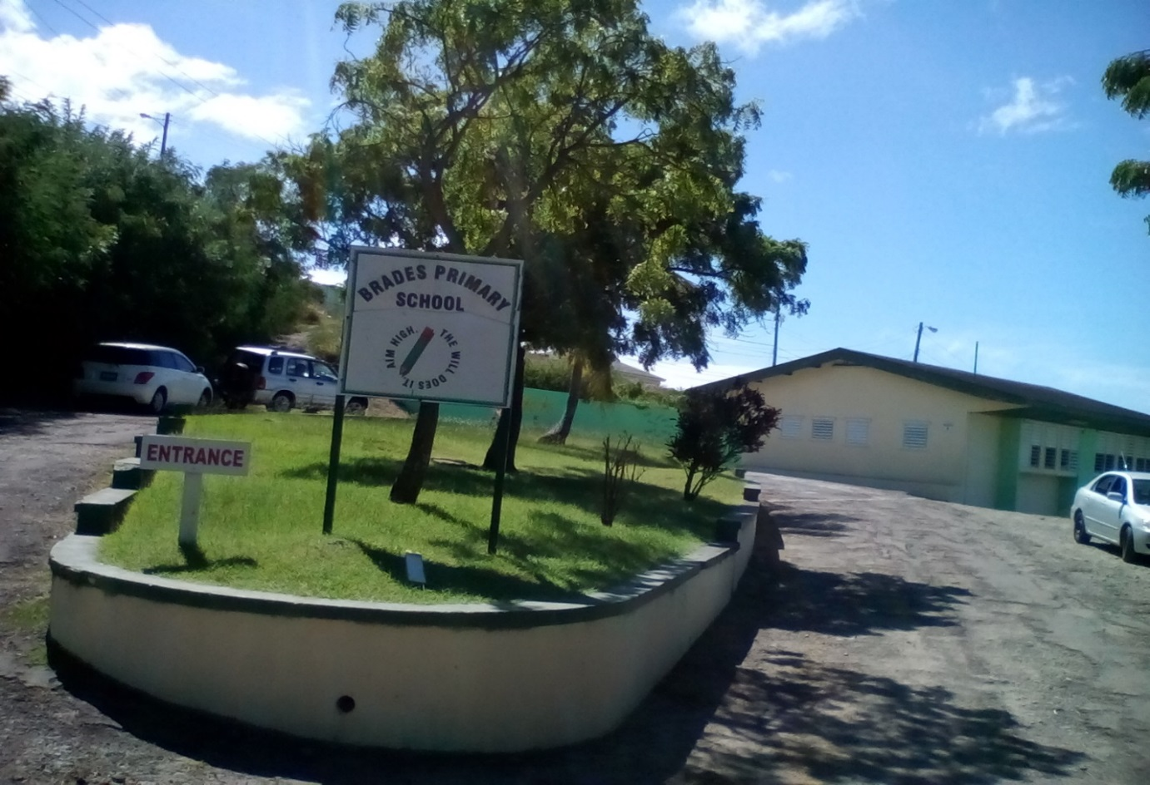
Polling Division 3 is located at the Brades Primary School and consists of two Polling Stations. This Polling Division is for persons living in the Brades area that comprises: Cudjoe Head, Baker Hill, Cavalla Hill, Nixons, Banks, Brades, Shinnlands and Manjack.

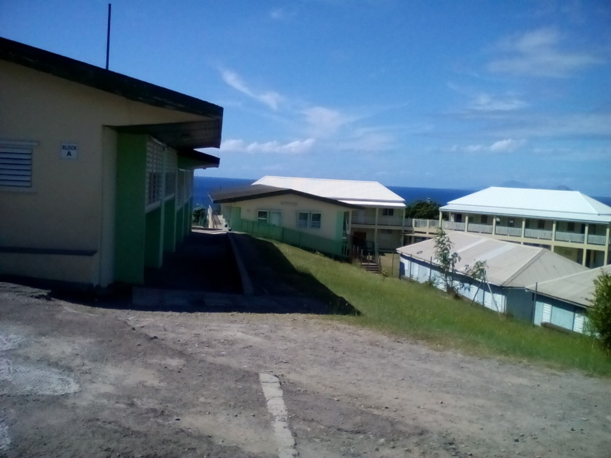
Persons with Surnames A- J would go to Polling Station # 1 and the Presiding Officer is Ms Denise Silcott

Persons with Surnames K-Z would go to Polling Station # 2 and the Presiding Officer is Mrs Inez Thompson.

POLLING DIVISION 4 – DAVY HILL AREA
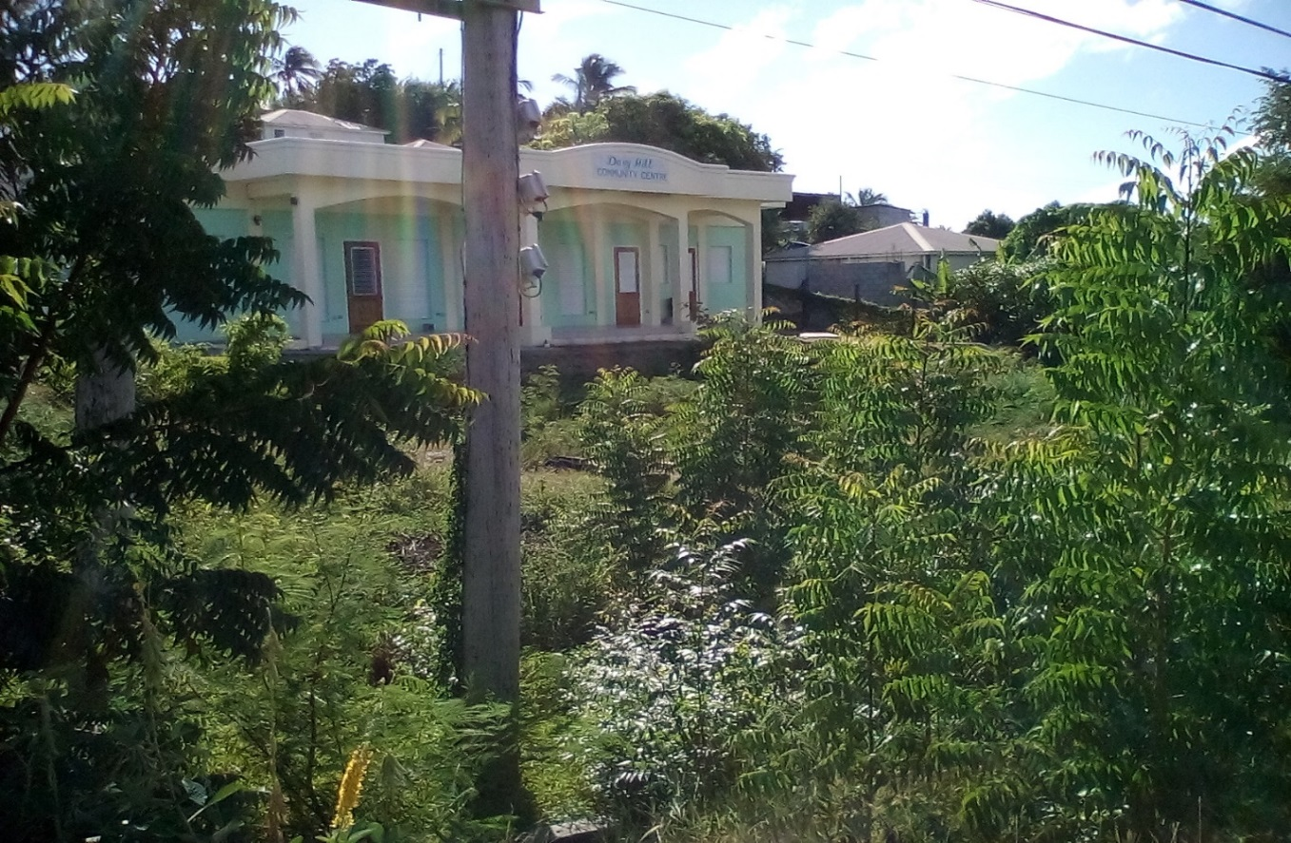
Polling Division 4 is located at the Davy Hill Community Centre and consists of two Polling Stations. This Polling Division is for persons living in the Davy Hill area that comprises: Carr’s Bay, Little Bay, Davy Hill, Sweeney’s, Old Norwood (left), Gerald’s, Drummonds, Rendezvous and Yellow Hill (left side from tank).

Persons with Surnames A- J would go to Polling Station # 1 and the Presiding Officer is Mrs. Patricia Farrell-Daway.
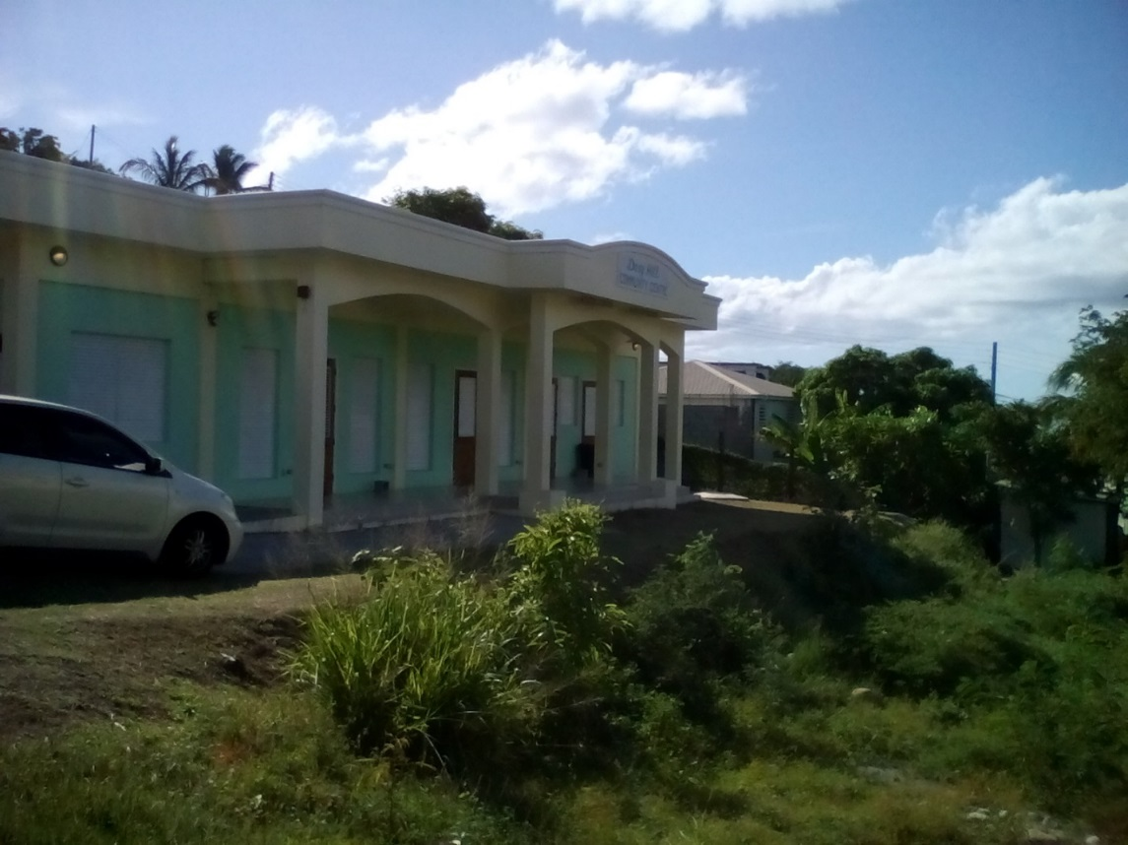

Persons with Surnames K-Z they would go to Polling Station # 2 and the Presiding Officer is Mrs Sarah J Lee.
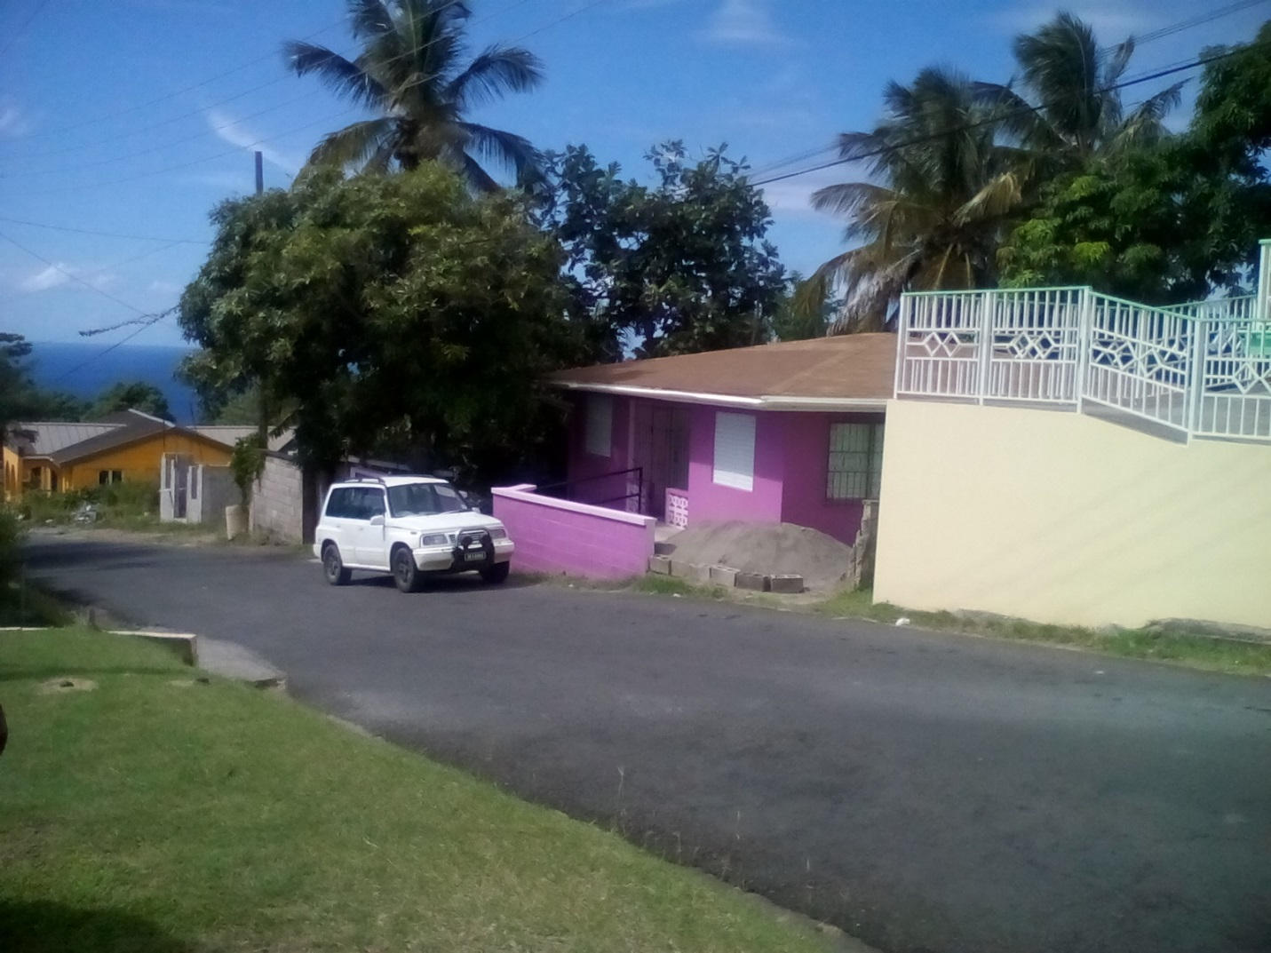
POLLING DIVISION 5 – ST. JOHN’S

Polling Division 5 is designated for the voters in the St.John’s area and consists of two Polling Stations. The St. John’s area comprises: Old Norwood (right), St.John’s, Mongo Hill, Dick Hill, Judy Piece, Barzey’s Yellow Hill (right side from tank) and Peaceful Cottage.

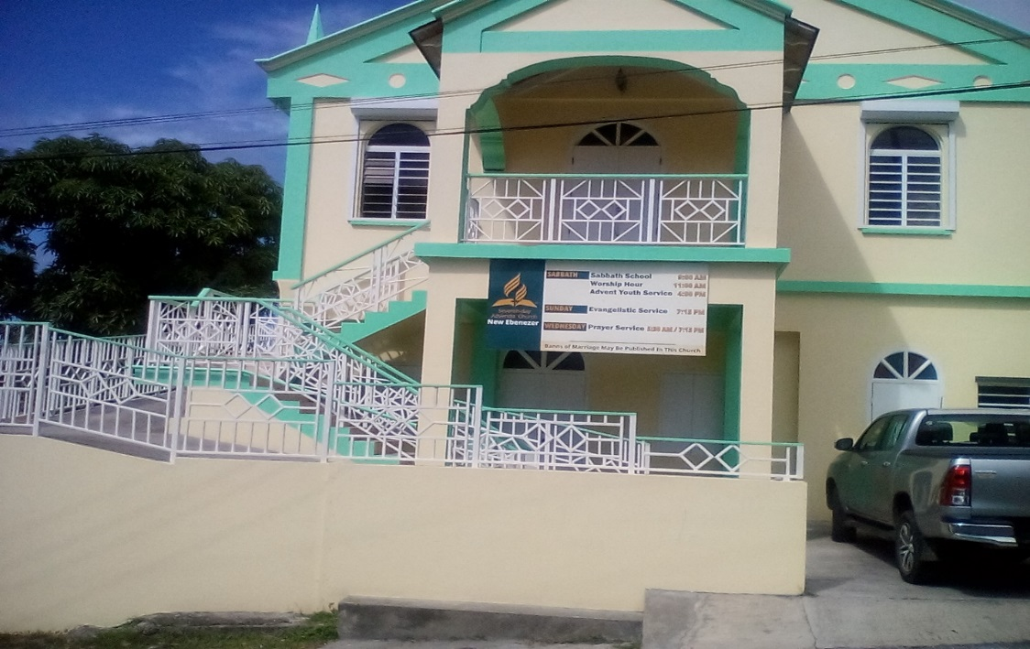
Persons with Surnames A- I would go to Polling Station # 1 (Adventist Church - Downstairs) and the Presiding Officer is Courtney Crump

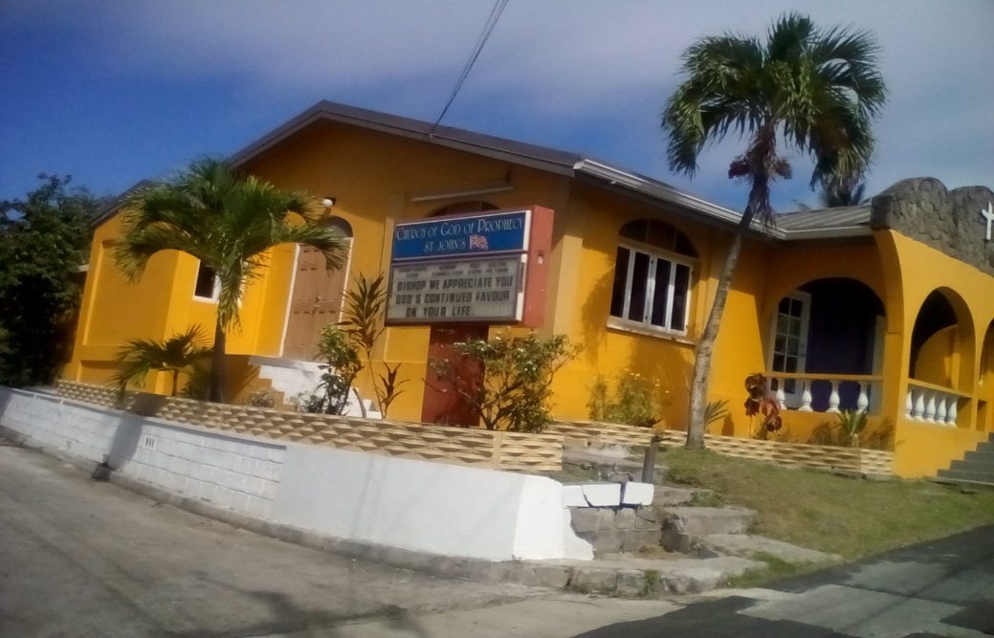
Persons with Surnames J- Z they would go to Polling Station # 2 (Church of God of Prophecy) and the Presiding Officer is Mrs. Rachael Kelly.

POLLING DIVISION 6 – LOOKOUT AREA
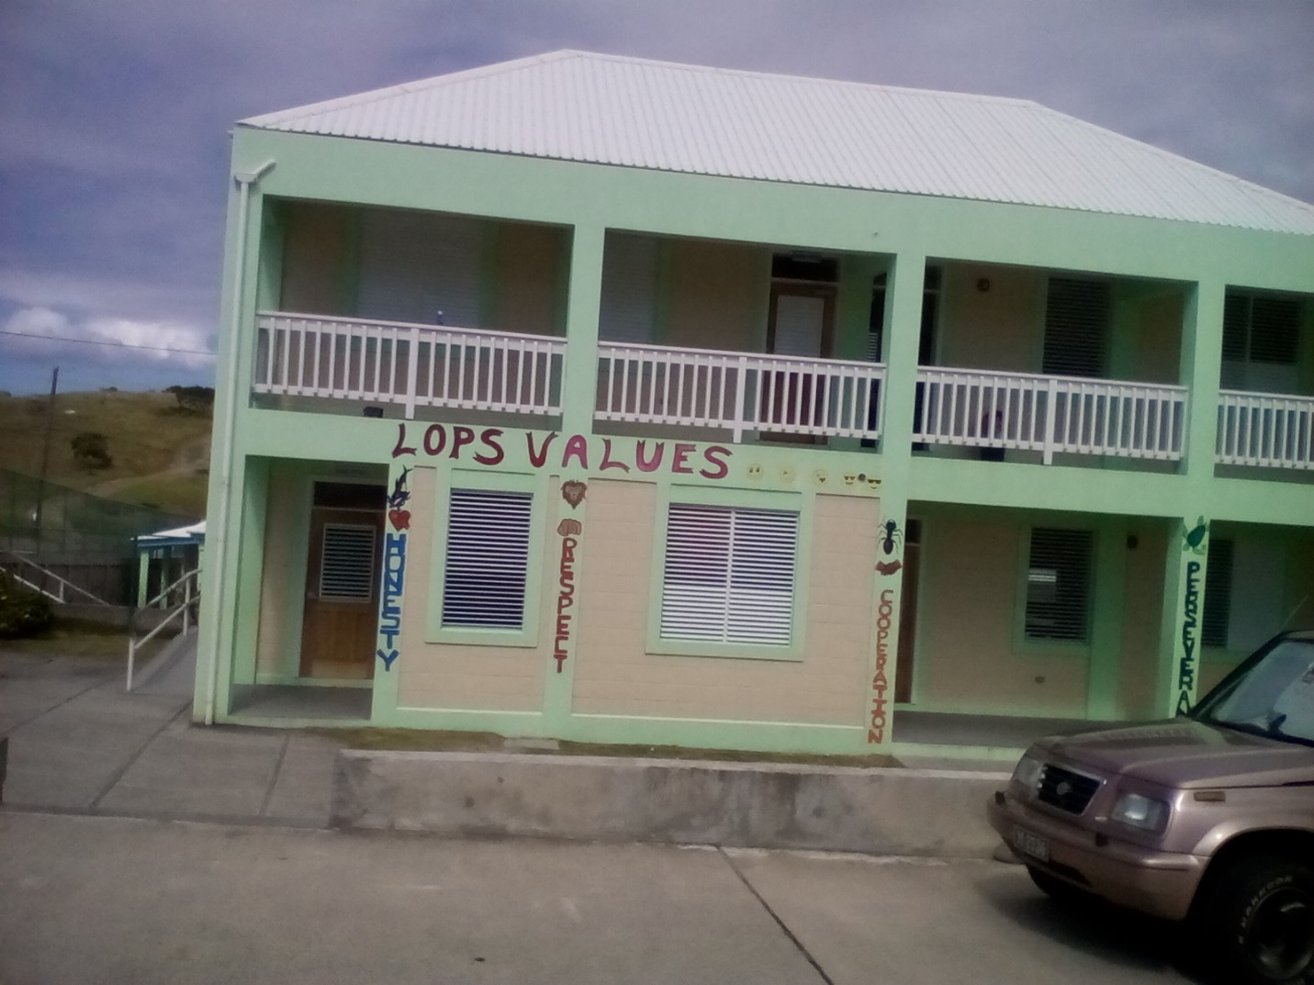
Polling Division 6 is located at the LookOut Primary School and consists of two Polling Stations. This Polling Division is for persons living in the LookOut area that comprises: all areas of Lookout, North of nothern main road, Quashie Spring, Brimm’s Ghaut and Eastern coastline.

Persons with Surnames A- K they would go to Polling Station # 1 and the Presiding Officer would be Marjorie Smith.

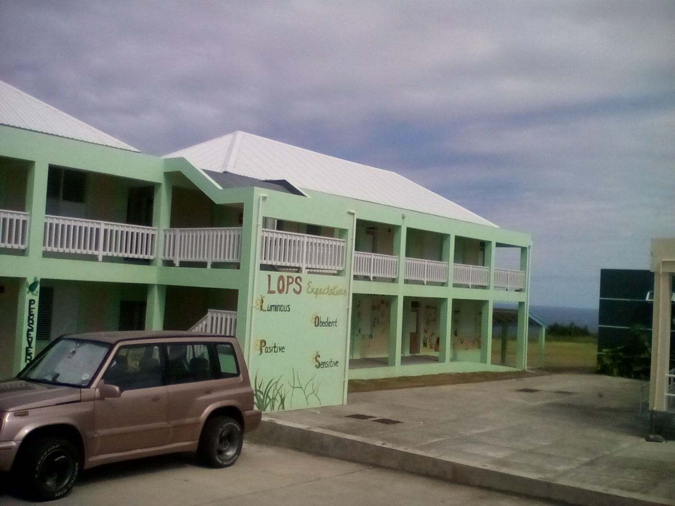

Persons with Surnames L-Z they would go to Polling Station # 1 and the Presiding Officer would be Delena Lynch-Mason.

